**What is GitHub?**

GitHub is a code hosting platform for version control and collaboration. It lets you and others work together on projects from anywhere.

## Step 1. Create a Repository

A **repository** is usually used to organize a single project. Repositories can contain folders and files, images, videos, spreadsheets, and data sets – anything your project needs. We recommend including a README, or a file with information about your project. GitHub makes it easy to add one at the same time you create your new repository. It also offers other common options such as a license file.

### To create a new repository

1. In the upper right corner, next to your avatar or identicon, click  and then select **New repository**.
2. Name your repository hello-world.
3. Write a short description.
4. Select **Initialize this repository with a README**.

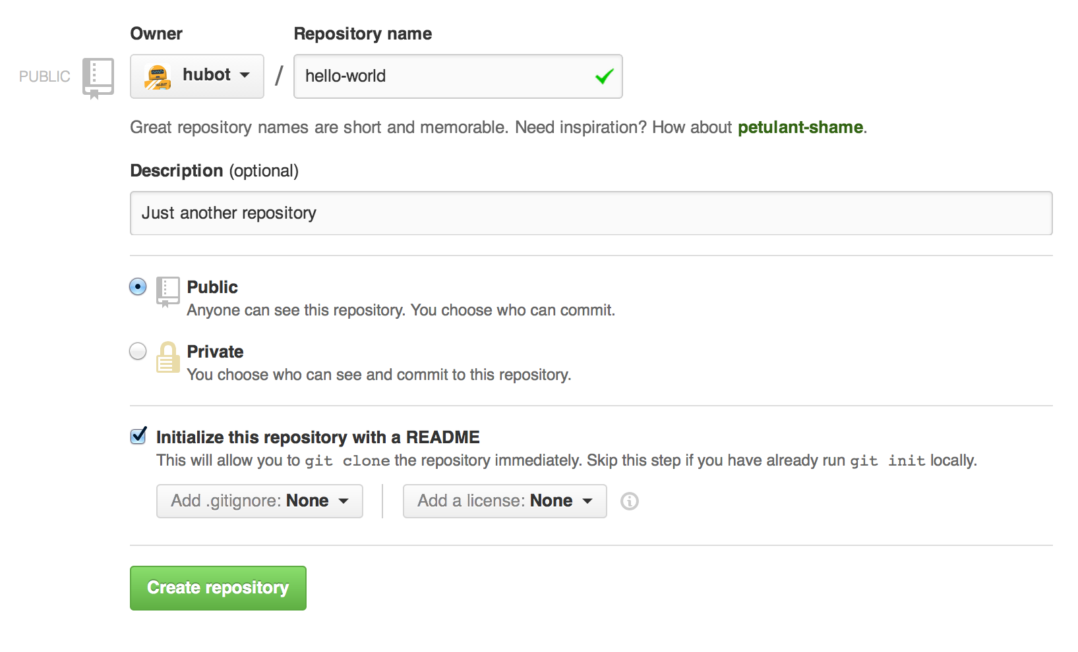

## Step 2. Create a Branch

**Branching** is the way to work on different versions of a repository at one time.

By default your repository has one branch named master which is considered to be the definitive branch. We use branches to experiment and make edits before committing them to master.

When you create a branch off the master branch, you’re making a copy, or snapshot, of master as it was at that point in time. If someone else made changes to the master branch while you were working on your branch, you could pull in those updates.

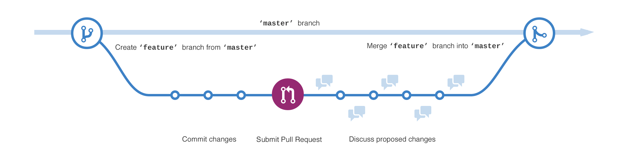

### To create a new branch

1. Go to your new repository hello-world.
2. Click the drop down at the top of the file list that says **branch: master**.
3. Type a branch name, readme-edits, into the new branch text box.
4. Select the blue **Create branch** box or hit “Enter” on your keyboard.



## Step 3. Make and commit changes

Bravo! Now, you’re on the code view for your readme-edits branch, which is a copy of master. Let’s make some edits.

On GitHub, saved changes are called commits. Each commit has an associated commit message, which is a description explaining why a particular change was made. Commit messages capture the history of your changes, so other contributors can understand what you’ve done and why.

#### Make and commit changes

1. Click the README.md file.
2. Click the  pencil icon in the upper right corner of the file view to edit.
3. In the editor, write a bit about yourself.
4. Write a commit message that describes your changes.
5. Click **Commit changes** button.

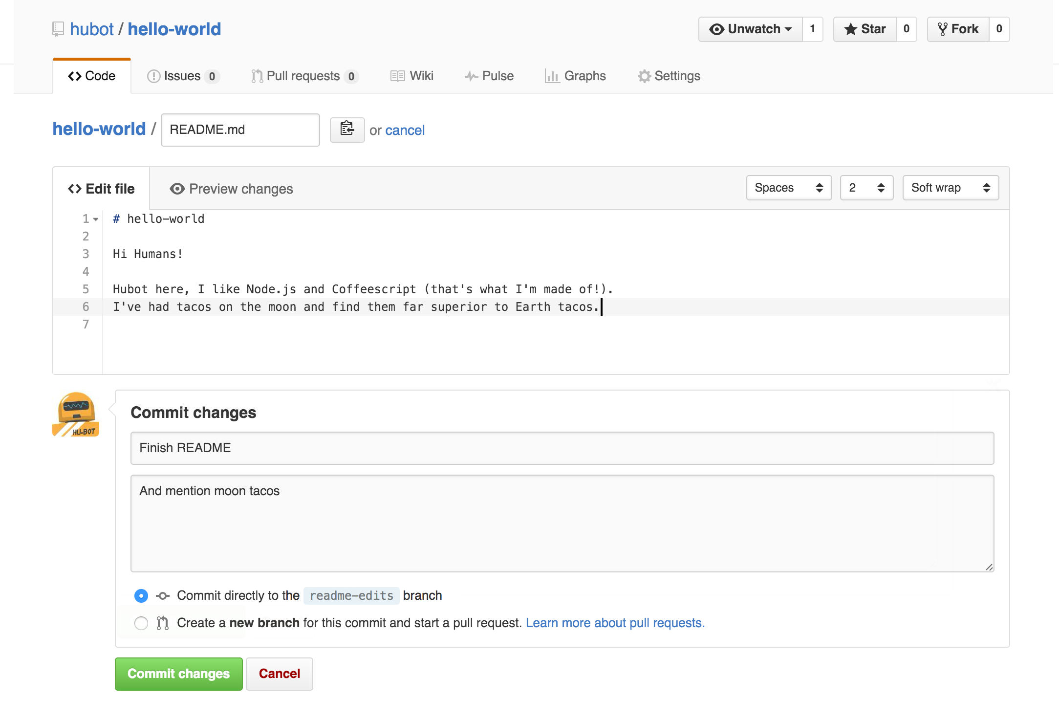

## Step 4. Open a Pull Request

Nice edits! Now that you have changes in a branch off of master, you can open a pull request.

Pull Requests are the heart of collaboration on GitHub. When you open a pull request, you’re proposing your changes and requesting that someone review and pull in your contribution and merge them into their branch. Pull requests show diffs, or differences, of the content from both branches. The changes, additions, and subtractions are shown in green and red.

As soon as you make a commit, you can open a pull request and start a discussion, even before the code is finished.

By using GitHub’s [@mention system](https://help.github.com/articles/about-writing-and-formatting-on-github/#text-formatting-toolbar) in your pull request message, you can ask for feedback from specific people or teams, whether they’re down the hall or 10 time zones away.

You can even open pull requests in your own repository and merge them yourself. It’s a great way to learn the GitHub Flow before working on larger projects.

#### Open a Pull Request for changes to the README

Click on the image for a larger version

#### Open a Pull Request for changes to the README

Click on the image for a larger version

When you’re done with your message, click **Create pull request**!

**Tip**: You can use [emoji](https://help.github.com/articles/basic-writing-and-formatting-syntax/" \l "using-emoji) and [drag and drop images and gifs](https://help.github.com/articles/file-attachments-on-issues-and-pull-requests/) onto comments and Pull Requests.

## Step 5. Merge your Pull Request

In this final step, it’s time to bring your changes together – merging your readme-edits branch into the master branch.

1. Click the green **Merge pull request** button to merge the changes into master.
2. Click **Confirm merge**.
3. Go ahead and delete the branch, since its changes have been incorporated, with the **Delete branch** button in the purple box.